**FOREX GUMP AND THE**

**Black-Litterman Model**

***Forex Gump****: My momma always said, "Life was like a box of chocolates. You never know what you're gonna get."*

Early in the millennium, active currency management was perhaps a little easier. Remember the days when carry and PPP were the main rival strategies in active currency management and trend was a cool alternative, as a combination of the two[1]?

Then the financial crisis and the credit crunch arrived and changed the game. Choppy markets and a roller-coaster of bumps in investor risk appetite decimated the performance of naïve strategies of either kind. While sophisticated strategies that perform can still be found, there is no consensus over the profitability of simple trading rules.

Other markets may have found consensus strategies, such as the Markowitz market portfolio in equity investing, (suboptimal, both in theory and practice, but popular for its tractability) and extrapolating past returns in guise of expectations (a poor strategy in most cases; see the bond market for an excellent illustration).

A good indicator of the FX environment can be gleamed from the performance of a family of DB naïve strategies’ indices (formerly RBS indices). Looking at Fig.1 one can get an inkling of the succession of risk tolerance regimes and their impact on the forex market during the last five - six years. As the financial crisis deepened, elevated risk expectations proved beneficial for volatility strategies (*DB G10 Carry Index*, see box) and shattering for carry (*DB G10 Carry Index*, see box).

When volatility started to fall, both these indices’ performances reversed. Recently, volatility in FX has fallen to almost pre-crisis levels, in spite of the financial crisis not being completely over yet[2], so plain carry may have a chance – but who can tell that volatility may not spike again?

*The indices proposed by the Deutsche Bank Index team are constructed in the following ways:*

*- The DB G10 Valuation Index (DBPPPUSF Index) trades long/short on the extreme departures from the PPP prediction. The strategy buys the three most undervalued currencies according to this measure, and sells the three most overvalued currencies. The exposures are reassessed every three months.*

*- The DB G10 Carry Index (DBHTG10U Index) ranks each quarter the G10 currencies by their three month interest rates. The strategy buys the top-three yielding currencies and sells the bottom-three yielding currencies.*

*- The DB G10 Momentum Index (DBMOMUSF Index) ranks currencies by their 12-month changes in spot exchange rates. The top-three performers are bought and the bottom-three currencies are sold. The ranking is reassessed every month.*

*- The DB Currency Volatility Index (CVIX Index) is not a strategy per se, but a representation of investors’ expectation of future volatility. The index is calculated as the arithmetic weighted average of the 3-month level of implied volatility of major currencies, based on the 4PM London BBA fixing.*

Fig. 1: Naïve Systematic Trading Strategies, Total Return Indices. 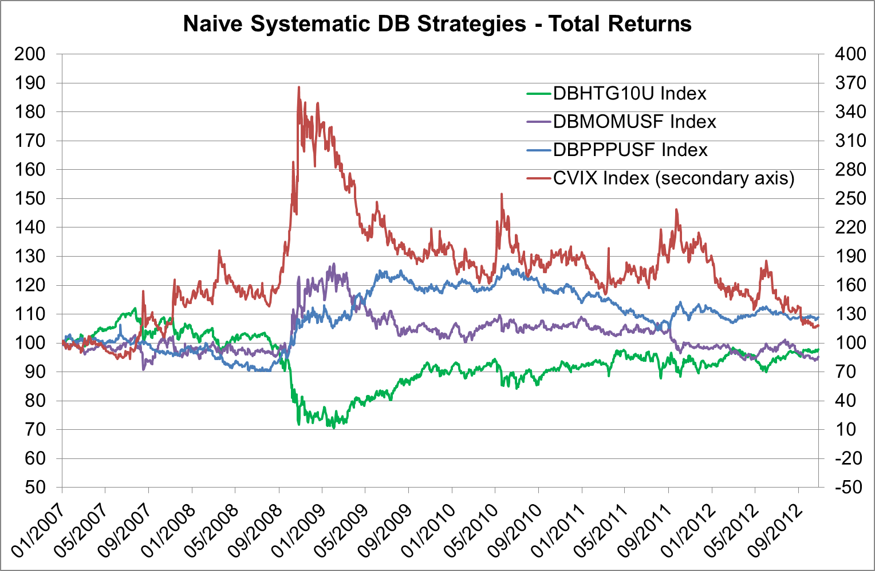

Since the beginning of 2007, none of the naive strategies have performed satisfactorily, except for brief periods. Sophisticated and large investors may find ways to extract information from market prices and events or collect arbitrage returns. Where simple strategies fail, what can the un-sophisticated investor do, absent computing power and analyst manpower? How can ruinous losses due to erroneous private expectations be avoided?

Is there an easy shortcut to a satisfactory trading strategy? In the following we illustrate the application of a possible solution – the Black-Litterman model, which combines a naïve strategy with an investor’s private views – and test it with real forex market data.

## Black-Litterman Model

***Forex Gump****: My Mama always said you've got to put the past behind you before you can move on.*

The Black-Litterman allocation model generates a portfolio by starting from a set of neutral weights (henceforth called *baseline portfolio*) and tilting it in the direction of investors’ views[3]. The size of the tilt depends on investor’s conviction. In its original form, the model updates the prior expectations resulting from an equilibrium market model with investor’s private views obtained from a proprietary model.

In the Black-Litterman portfolio, the weight of an asset is higher than its analogue in the *baseline portfolio* if the investor is more bullish than the market on that particular asset, and vice versa. In addition, the weight increment is higher as the investor’s confidence in the view, also called the view strength, grows.

We start by specifying the baseline model and calculating prior *baseline expectations*. Then we construct *private views* and the investor’s confidence in the views (strength). Finally, we update the baseline expectations with the private views tempered by their strength.

1. **Baseline Portfolio**

***Forex Gump****: Stupid is as stupid does.*

In the following, we shall apply the model to the G7 FX market. We do not make use of a market portfolio of G7 currencies[4]. Instead, we will use as baseline portfolio a naïve carry strategy, whereby the investor buys long a currency pair if it is associated to a positive interest rate differential. Eg., if the key interest rate in AUD is 4.5% and in CHF it is 2.0%, the investor will allocate a portion of its trading portfolio to the AUDCHF pair, that is, long AUD and short CHF. In the naïve model, the proportions allocated to each currency pair are equivalent.

The advantage of this baseline portfolio is its obvious simplicity and ease of construction. Besides, in “normal” times, such a portfolio may even perform, as empiricists have shown. However, in times of turmoil, the currencies used for funding carry trades quickly become “safe havens” and carry profits reverse. Returning to the DB G10 Carry Index in Fig.1, we see that the index lost about 30% in the bleak autumn of 2008. While it has performed relatively well since 2009, there is no guarantee that bad times will not occur again (just consider the ongoing euro crisis and the possibility of a black swan event). Entering private views in the portfolio through a Black-Litterman model may shield the investor from ruin or substantial drawdowns in such eventuality.

Our naïve portfolio is a buy and hold allocation beginning in 2007 and carried until 26 October 2012. According to the average sovereign interest rates at the beginning of 2007, such a portfolio would have allocated equal parts to the following seventeen currency pairs: AUDJPY, AUDCHF, AUDEUR, AUDCAD, GBPEUR, GBPCAD, GBPCHF, GBPJPY, USDEUR, EURJPY, EURCHF, EURCAD, CADJPY, USDCHF, USDJPY, USDCAD and CHFJPY. Interest rate differentials have changed since then, but our baseline strategy does not take the changes into account.

Given the naïve weights and the observable covariance matrix of the currency pairs held in the portfolio, the implied or *reverse* return expectations of the naïve investor can be calculated. We will call these *baseline* or *prior expectations[5]*.

1. **Private Views**

***Recruit Officer****: Have you given any thought to your future, son?****Forex Gump****: "Thought?"*

The original Black-Litterman model provides no guidance in setting the private views. These views may come from anywhere: media, analyst forecasts or factor models. We prefer the latter. First, because we are adepts of systematic trading. Second, because econometric estimations produce not only expected values (views), but also standard errors of estimates (view strengths).

To keep things simple, our factor model uses as single factor the past 22 working days’ returns series in each currency pair. The private views consist of extrapolations of the daily rolling 22-day average and they have a confidence matrix attached in the form of the standard error of the 22-day average estimates. In our example, the views on a currency pair are independent from the views on other currency pairs, but this assumption can be relaxed.

A mean-variance investor having full confidence in this view would allocate the portfolio entirely according to the views, the risk aversion (which we infer from the realized returns of the baseline portfolio, assuming the expectations are realized) and the covariance matrix between the currency pairs.

1. **Updated returns and BL portfolio**

***Forex Gump****: Mama always had a way of explaining things so I could understand them.*

Both portfolios obtained at **A** and **B** result in unacceptable return patterns (for any sane investor). As shown in Fig.2, the baseline portfolio accumulates losses, while a portfolio built solely from the private views is extremely volatile. One is too naïve, while the other ignores the degree of uncertainty contained in the views. Luckily, an improved allocation can be achieved by combining the views with the baseline model while taking into account the views’ strength.

The Black-Litterman asset allocation model uses the Bayesian approach to infer the assets’ expected returns. The inference starts with a prior belief, embedded, here, in the naïve allocation (originally, the prior beliefs were market equilibrium returns). Additional information is derived from the private views and used along with the prior beliefs to infer the posterior distribution of expected returns. We may also call these expected returns *posterior views*[6].

The posterior views are in the form of updated expected returns and an updated covariance matrix. These are used in conjunction in order to construct optimal portfolio weights, using a Markowitz mean-variance optimization.

Fig.2. Naïve Carry, Private Views and Black-Litterman Portfolios, Total Return Indices  
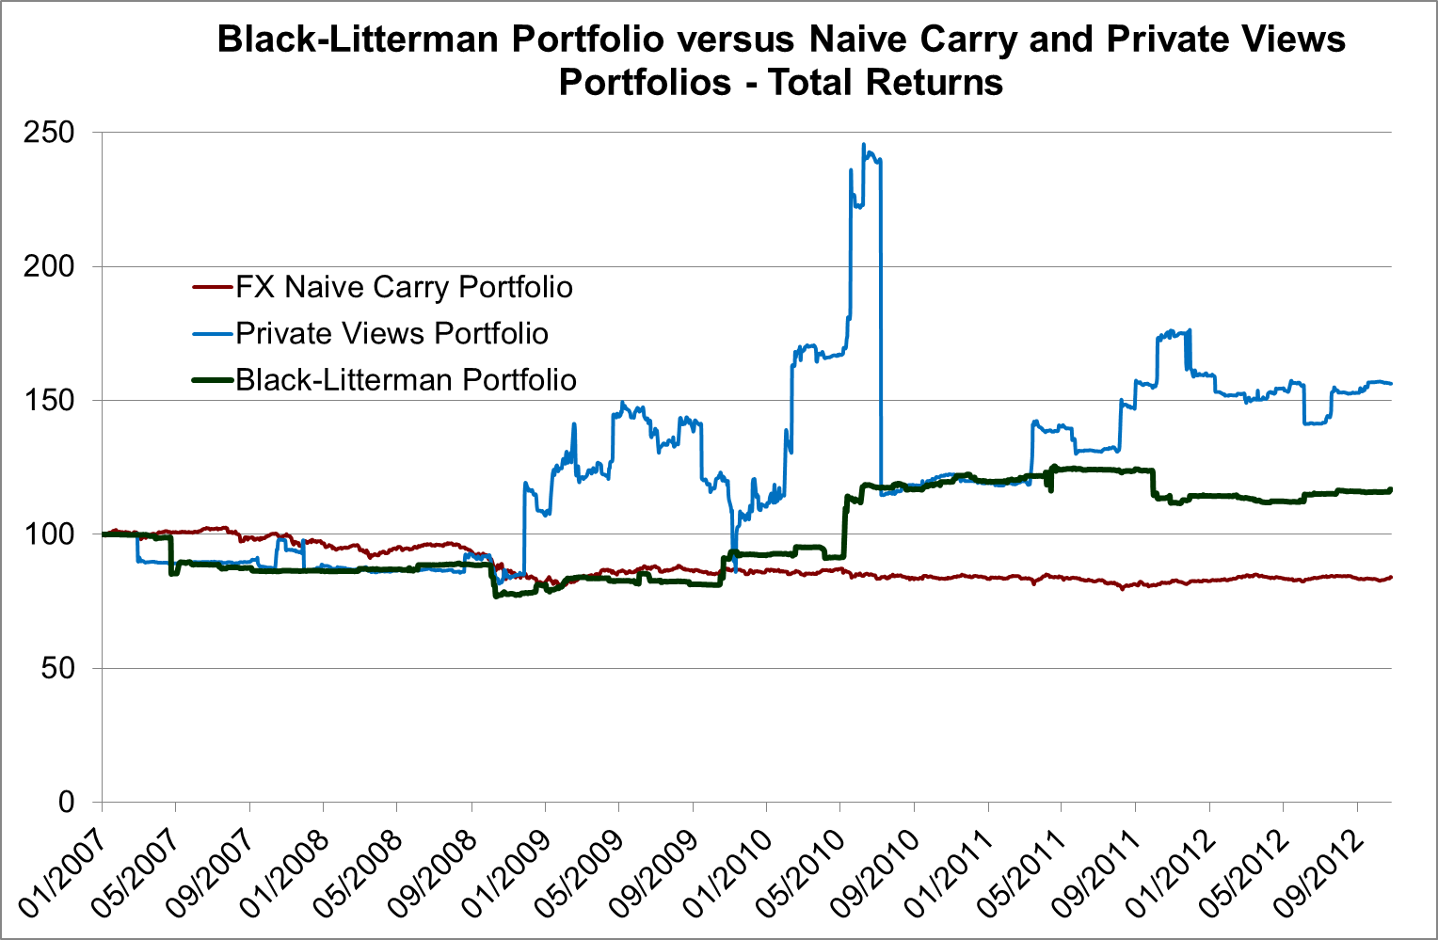

## Black-Litterman Model Results

***Forex Gump****: What's my destiny, Mama?****Mrs. Gump****: You're gonna have to figure that out for yourself.*

We have tested the procedure using the methodology outlined in the paper “Global Portfolio Optimization” by F. Black and R. Litterman and in the “*Investments*” book by F. Bodie, A. Kane and A. J. Markus. A number of other papers such as T. M. Idzorek’s “A Step-By-Step Guide to the Black-Litterman Model” were of great help in understanding the Black-Litterman methodology as well.

We find that the portfolio obtained by applying the Black-Litterman procedure outperforms both the baseline portfolio and the private views portfolio on average for a number of criteria, displayed in Table 1. Drawdowns are significantly improved both in size and duration, as displayed in Fig.3. The Kernel distribution of returns in Fig.4 shows that the Black-Litterman portfolio distribution of returns has volatility comparable with that of the baseline portfolio, and significantly lower than that of the private views portfolio.

The results are not excellent but satisfactory, considering the fact that we started from a very naïve baseline portfolio and a very basic rule for constructing the private views. The results can be improved by refining these views. Nevertheless, we find that there is great value in applying the Black-Litterman model to reduce the calamitous effect of misguided private views.

Fig.3. Naïve Carry, Private Views and Black-Litterman Portfolios, Drawdowns

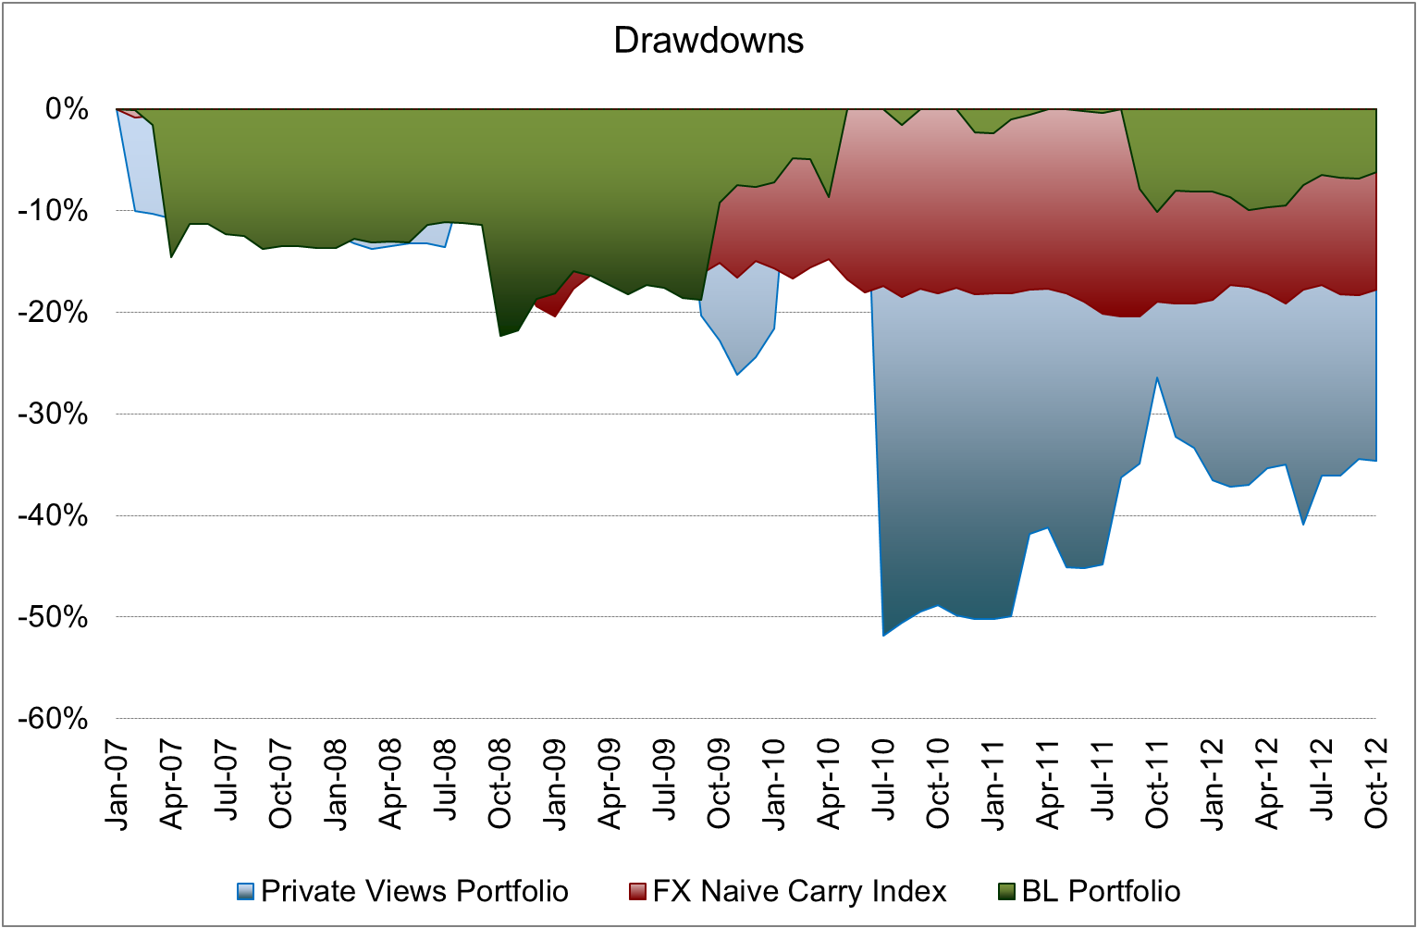

Fig.4. Naïve Carry, Private Views and Black-Litterman Portfolios, Kernel Distribution

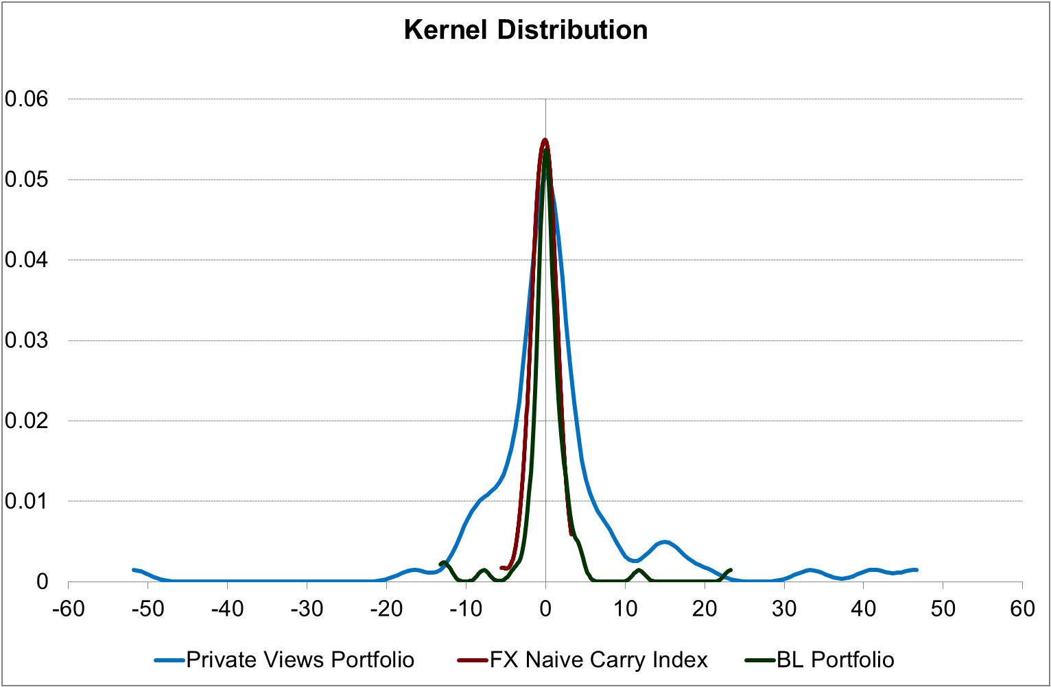

**Global Disclaimer**

This report has been prepared by Insch Capital Management SA, referred to herein as “Insch”.

The figures contained in performance charts refer to the past; past performance is not a reliable indicator of future results. Additional information will be made available upon request.

This report is for distribution only under such circumstances as may be permitted by applicable law. Nothing in this report constitutes a representation that any investment strategy or recommendation contained herein is suitable or appropriate to a recipient’s individual circumstances or otherwise constitutes a personal recommendation. It is published solely for information purposes, it does not constitute an advertisement and is not to be construed as a solicitation or an offer to buy or sell any securities or related financial instruments in any jurisdiction. No representation or warranty, either express or implied, is provided in relation to the accuracy, completeness or reliability of the information contained herein, except with respect to information concerning Insch, its subsidiaries and affiliates, nor is it intended to be a complete statement or summary of the securities, markets or developments referred to in the report.

Insch does not undertake that investors will obtain profits, nor will it share with investors any investment profits nor accept any liability for any investment losses.

Investments involve risks and investors should exercise prudence in making their investment decisions. The report should not be regarded by recipients as a substitute for the exercise of their own judgment. Past performance is not necessarily a guide to future performance. The value of any investment or income may go down as well as up and you may not get back the full amount invested. Any opinions expressed in this report are subject to change without notice and may differ or be contrary to opinions expressed by other business areas or groups of Insch as a result of using different assumptions and criteria. Research will initiate, update and cease coverage solely at the discretion of Insch. The analysis contained herein is based on numerous assumptions. Different assumptions could result in materially different results. The analyst(s) responsible for the preparation of this report may interact with trading desk personnel, sales personnel and other constituencies for the purpose of gathering, synthesizing and interpreting market information. Insch is under no obligation to update or keep current the information contained herein. The compensation of the analyst who prepared this report is determined exclusively by research management and senior management. Analyst compensation is not based on investment revenues, management fees, performance fees or commissions, however, compensation may relate to the revenues of Insch as a whole.

The securities described herein may not be eligible for sale in all jurisdictions or to certain categories of investors. Options, derivative products and futures are not suitable for all investors, and trading in these instruments is considered risky. Foreign currency rates of exchange may adversely affect the value, price or income of any security or related instrument mentioned in this report. For investment advice, trade execution or other enquiries, investors should seek professional advice.

Neither Insch nor any of its affiliates, nor any of directors, employees or agents of Insch accepts any liability for any loss or damage arising out of the use of all or any part of this report.

Any prices stated in this report are for information purposes only and do not represent valuations for individual securities or other instruments. There is no representation that any transaction can or could have been effected at those prices or theoretical model-based valuations and may be based on certain assumptions. Different assumptions, by Insch or any other source may yield substantially different results.

The disclosures contained in research reports produced by Insch shall be governed by and construed in accordance with Swiss law.

Insch specifically prohibits the redistribution of this material in whole or in part without the written permission of Insch and Insch accepts no liability whatsoever for the actions of third parties.

**This document contains opinions of instruments and markets as of the date of issue. The document is provided for information purposes and does not constitute an investment offer or solicitation.**

**Insch Capital Management SA conducts investment research across a broad range of financial and commodity markets.**

**Insch Capital Management SA will also undertake external research projects on a consultancy basis for third parties.**

**For further information regarding this report or research requests, please contact:**

**Christopher L. Cruden**

**Chief Executive Officer**

**clc@**[**inschinvest.com**](mailto:info@inschinvest.com)

**Purnur Schneider, FRM**

**Head of Research**

**purnur@**[**inschinvest.com**](mailto:info@inschinvest.com)

**Insch Capital Management SA**

**Corso Elvezia14**

**CH 6900 Lugano**

**Switzerland**

**E-Mail:** [**info@inschinvest.com**](mailto:info@inschinvest.com)

**Phone: +41 (0) 91 921 0168**

**Fax: +41 (0) 91 921 4078**

**Website: www.inschinvest.com**



1. See our arguments in findings in the Insch paper [The Trend Can Be Your Friend](http://www.inschinvest.com/downloads/download.php?id=26), May 2011
2. See our expectations for Q4 2012 in the *Hedge Funds Review*, [Credit strategies tipped as top choices for smart money moving into hedge funds in fourth quarter](http://www.hedgefundsreview.com/hedge-funds-review/feature/2207749/credit-strategies-tipped-as-top-choices-for-hedge-fund-strategies-in-fourth-quarter),
3. Fischer Black and Robert Litterman, “Global Portfolio Opimization”, *Financial Analysts Journal*, 1992.
4. We are not aware if such a portfolio is known, although we guess it can be estimated.
5. In the FX market we may consider the returns from trading the currency pairs to be excess returns; we can ignore thus the existence of a risk-free rate. For simplicity, we use ‘return’ to refer to ‘excess return over the risk free rate’.
6. The updating formulas are found in the paper “Global Portfolio Opimization” by F. Black and R. Litterman.